Intake Sheet, page 1, Shaded Area
1: No | 2: No | 3: Yes | 4: Yes | 5: Yes

Filing Status - Married Filing Jointly
Federal Refund - $4,703
State Refund - $724

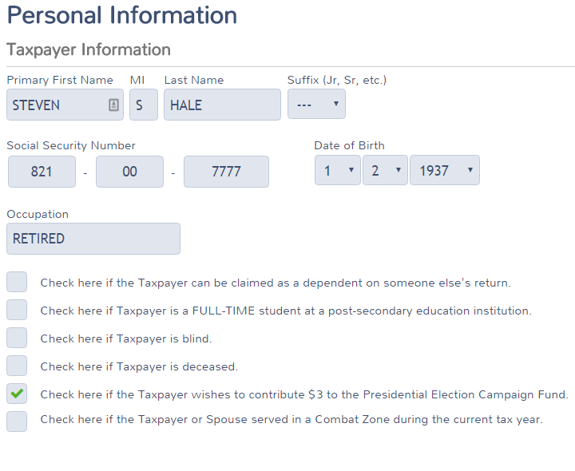
Basic Information

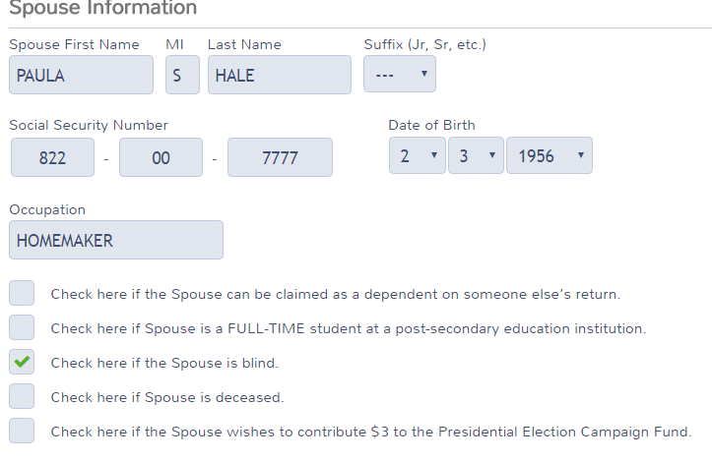

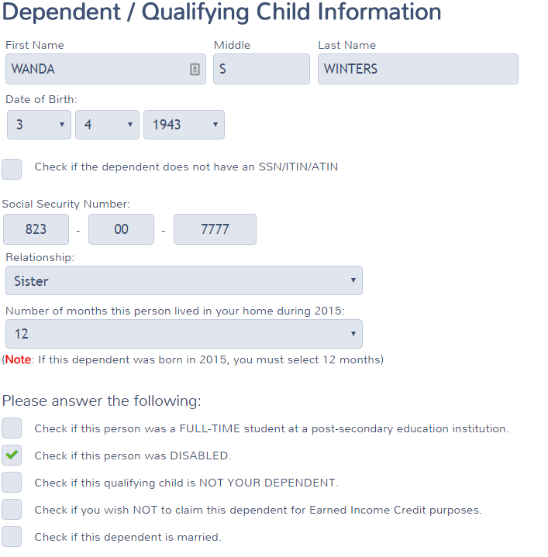
Interest
ACME Brokerage
Box 1 =125
Box 3 = 506
Box 4 = 50
Savings Bond Interest subtracted from NJ = 506

ACME Brokerage Tax Exempt Interest
Federal = 338
Taxable New Jersey Amount = 189

Dividends
ACME Brokerage
Box 1a = 232
Box 1b = 125
Box 2a = 69
Box 3 = 32
Box 4 = 80
Box 6 = 44

ACME Brokerage – Tax Exempt Interest Dividends
Federal = 400
Taxable New Jersey Amount = 154

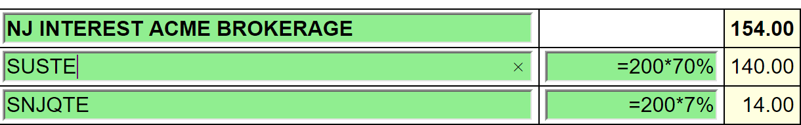
For SUSTE (Not a NJ qualified fund), only the District of Columbia, Puerto Rico and US Possessions
are exempt. 30% is exempt. 70% is taxable.

For SNJQTE (A qualified NJ fund), all the above plus the 70% New Jersey is tax exempt. 93% is
exempt. 7% is taxable.

Private Activity Bond Interest amounts are entered on AMT Form 6251. Use a scratch pad to total all the PABs in the return. If AMT is generated the return is out of scope. See form below.

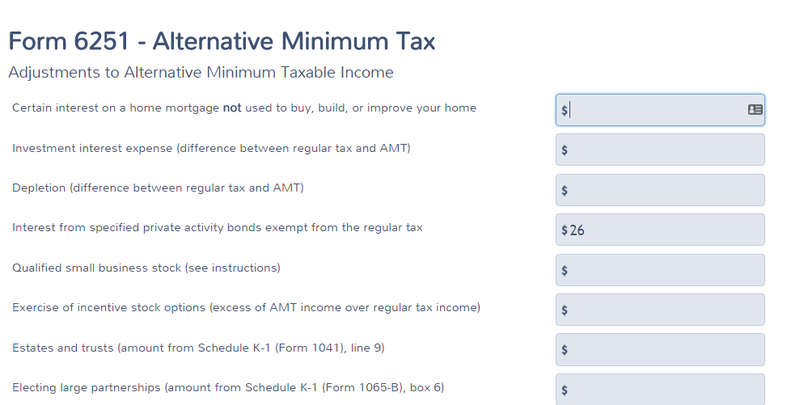

1099-R

ACME Pensions
Stephen Hale checked
Box 1 = 23,793
Box 2a = 23,793
Box 4 = 2,379
Box 7 = 7

Office of Personnel Management
Stephen Hale Checked
Box 1 = 18,625
Box 2a = 18,006
Box 4 = 1,862
Box 5 = 2,300 – This amount should be put in Sch A Medical – Insurance
Box 7 = 7
Box 9b = 15,984
Box 12 = 700
Box 13a = New Jersey
Box 14 = 18,006

Difference between Box 1 and Box 2a to be entered on the NJ Checklist

Simplified Rule Worksheet - See Bogart Annuity Calculator Print Out – Best practice is to
use the Bogart Calculator to determine the correct numbers and insert into the TSO
worksheet. If TP or Spouse is a public safety officer, insert the calculated amount from
the Bogart Calculator directly into line 2a of the 1099-R.
    - Plan Cost 15,984
    - Start Date 2/1/2008
    - Check Joint Annuity Box
    - Age of recipient at start date – 122
    - Number of months paid in 2015 – 12
    - Amounts previously recovered – 4281
Taxable amount Box 2a – 18,006

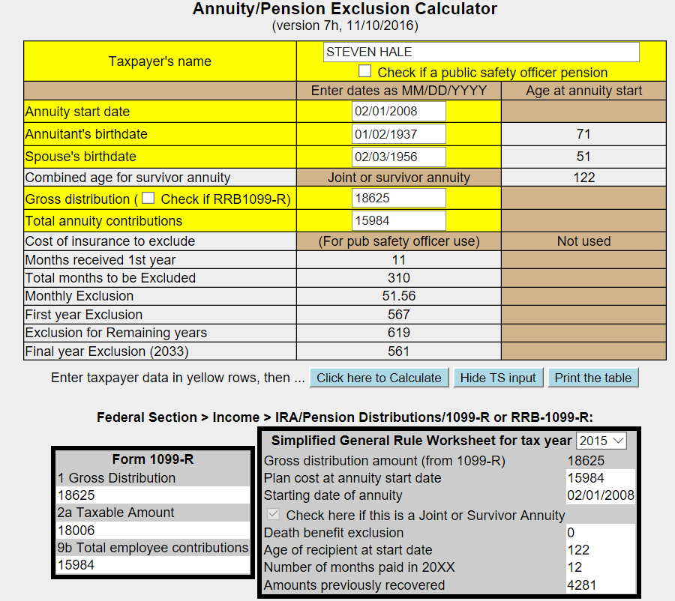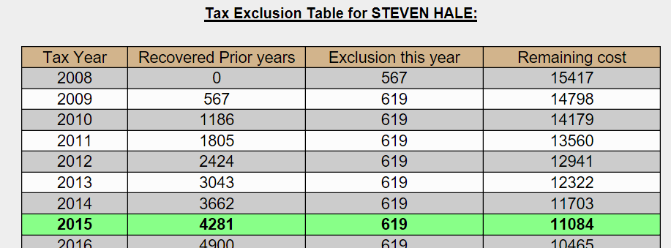

ACME IRAS
Paula Hale checked
Box 1 = 1,000
Box 2 = 1,000
Box 4 = 100
Box 7 = 7
IRA Box Checked

Question 1 – If she took a distribution in June she would not have been 591/2 and would have be
subject to a 10% penalty.

Question 2 – The TP was in a 10% tax bracket. The $100 withholding was the exact amount of the tax
increase.

SSA-1099
Benefit = 15972
Federal Tax Withheld = 550
Medicare Premiums = 2,195

Capital Gains
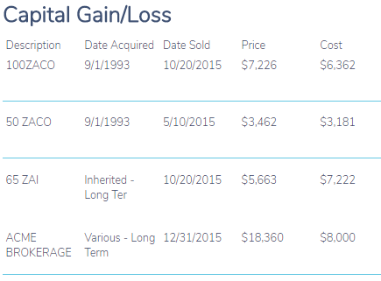
Cost Basis Not Reported
Cost Basis Not Reported
Cost Basis Not Reported
Cost Basis Reported

- ZAI – Check that Wash sale was entered
  - Adjustment description = “Nondeductible loss from wash sale”

- ACME Brokerage – Consolidated entry –
  - Description – ACME Brokerage
  - Adjustment description = “Reporting Multiple Transactions on a Single Row”

- Other Capital Gains Data – Long Term Carryover = 12,454

K-1

Entity Information
- Be sure Form 1065 was used and Entity Information should be checked as shown below:
- Steven Hale checked

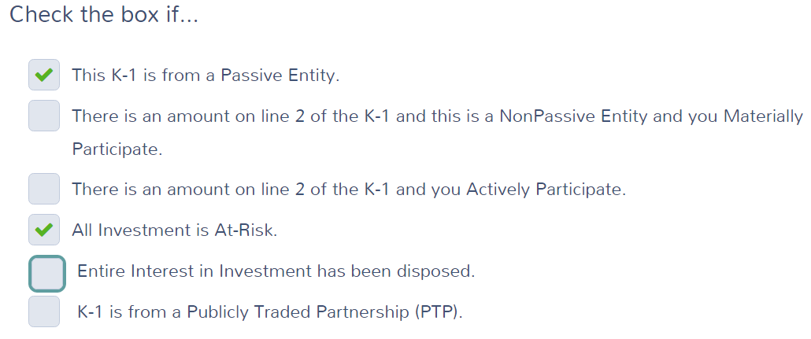
Income
Box 5 = 343
Box 6a = 474
Box 6b = 101
Box 7 = 976
Box 8 = 72
Box 9a = 218
Box 18A = 31

Gambling Winnings
- For spouse
- Winnings = 10,000
- Federal Tax Withheld = 2,000
- Type of wager = Lottery
- Date Won = 7/15/2015

Log total gambling winnings in the NJ checklist

Gambling losses should be entered on Sch A

Estimated Tax Payments

State Estimated Payments
4/15 = 60
6/15 = 60
9/15 = 60
12/31 = 70
Note: The $50 NJ estimated payment made on 1/3/2015 for TY 2014 is not entered here. See Itemized deductions – Taxes You Paid.

Itemized Deductions

- Taxes You Paid

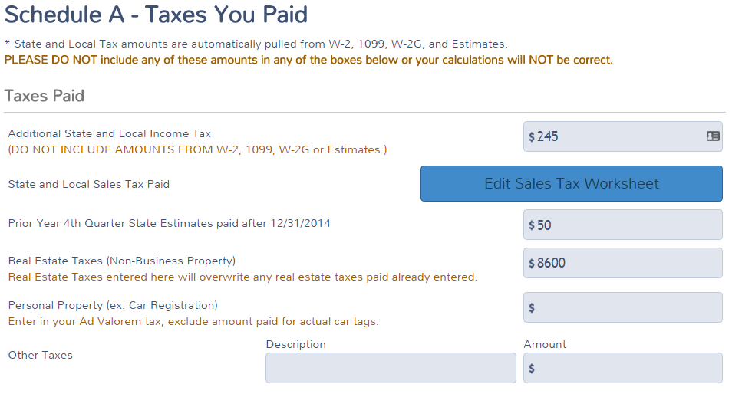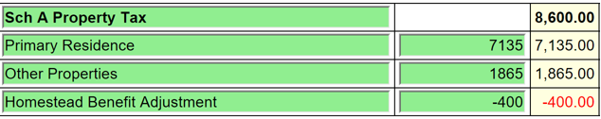
Estimated tax payments to NJ made on 1-3-15 for TY2014.
1. 203 paid for last year’s taxes plus
2. 42 paid for taxes owed from three years ago

Sales Tax Worksheet
  - Enter NJ and days

- Medical
  - Medical Insurance

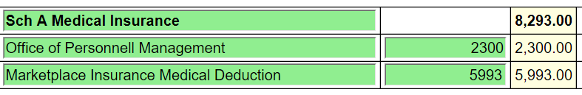

  - Doctors = 300

  - Long term care
    - Be sure Paula is selected from the drop-down menu for long term care insurance
      - Amount = 1,800 (Amount on Sch A reduced due to limitation based on age)

- Mortgage Interest
  - Mortgage Interest Reported on Form 1098
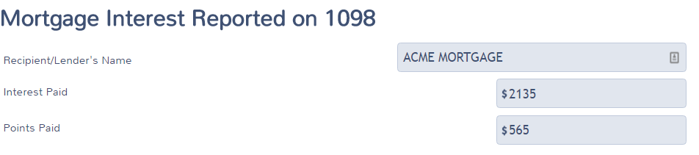
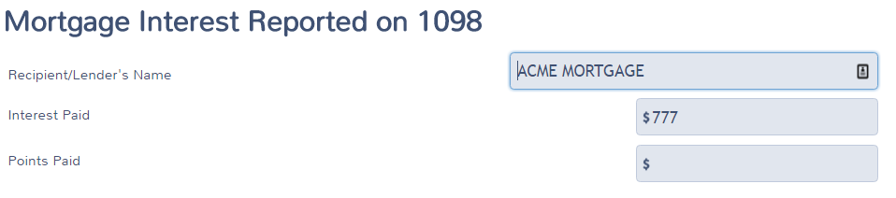

  - Primary Mortgage Insurance (PMI) Deduction
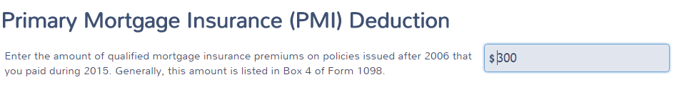

- Gifts to Charity
  - Cash = 600

- Misc. Deductions
  - Gambling Losses
    - Gambling Losses = 10,000. Cannot exceed winnings.

- Health Insurance
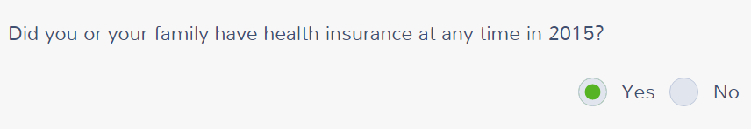

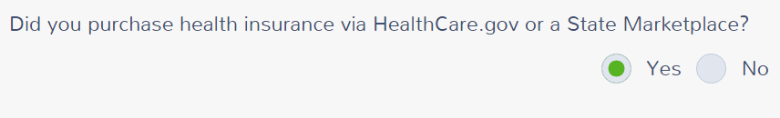

Verify your Household Members – CONTINUE

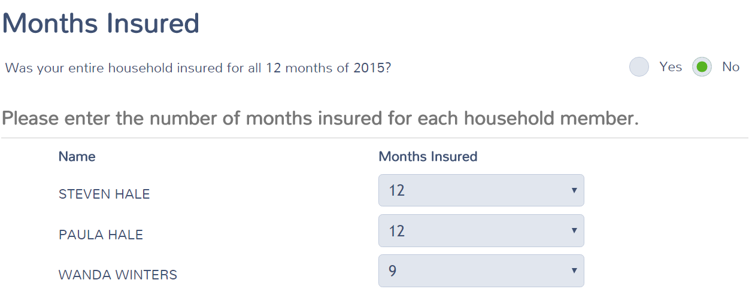

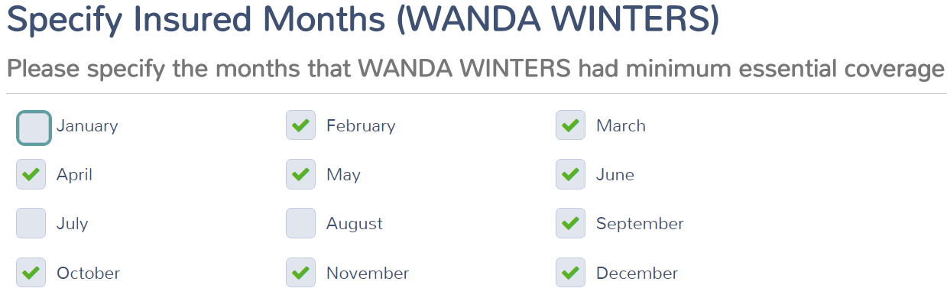

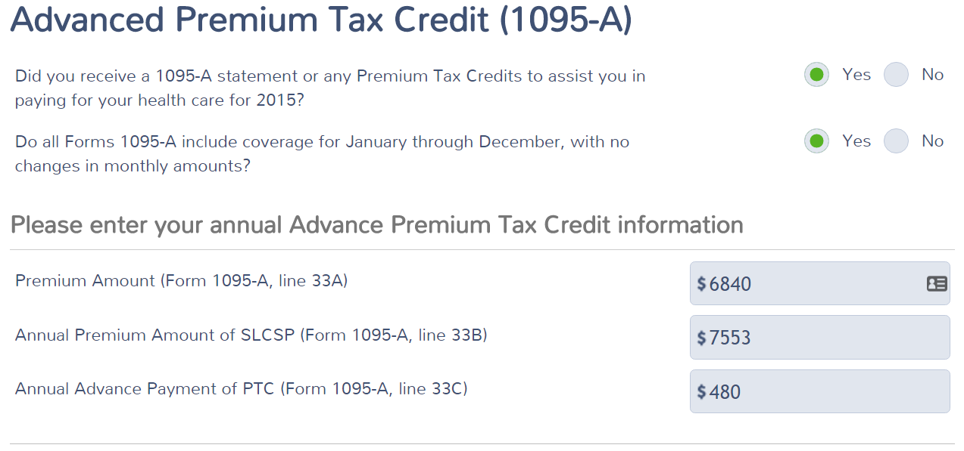

Dependents' Modified AGI (if filing requirement) - None – CONTINUE

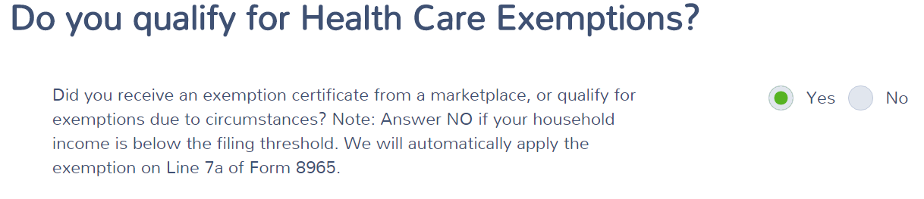

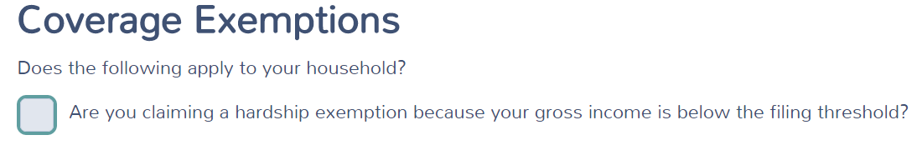

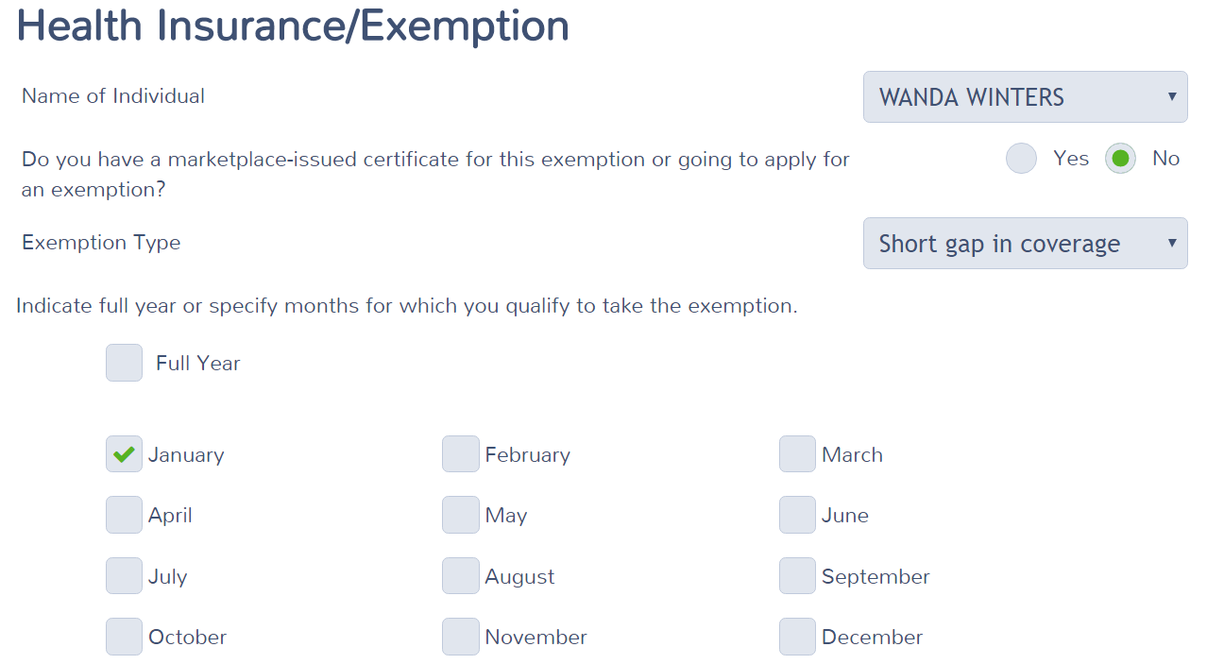

Medical Insurance Deduction for Marketplace coverage

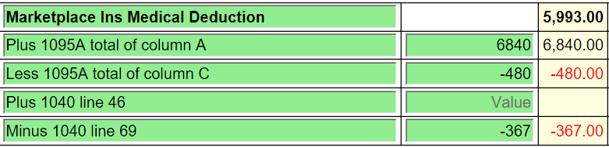
8,293 total medical insurance on Sch A Medical

New Jersey Return

Check that the numbers shown in the NJ Checklist below have been properly entered in to TaxSlayer.

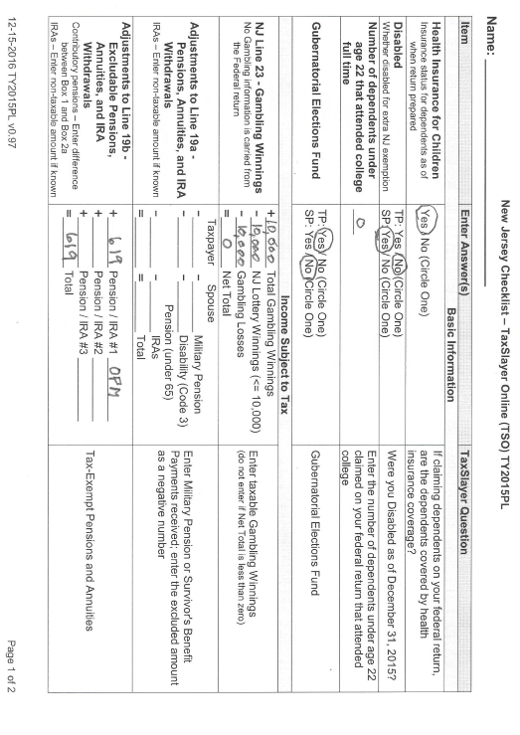

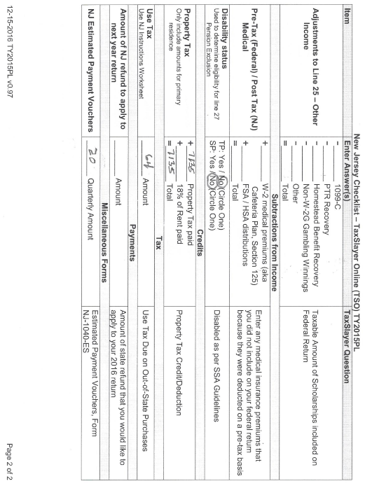
Blk-50001
Lot-00002

Note : Property Tax Credit. Did you meet Property Tax Eligibility Requirements?
Where you a homeowner in 2015?
Yes, to both questions.

